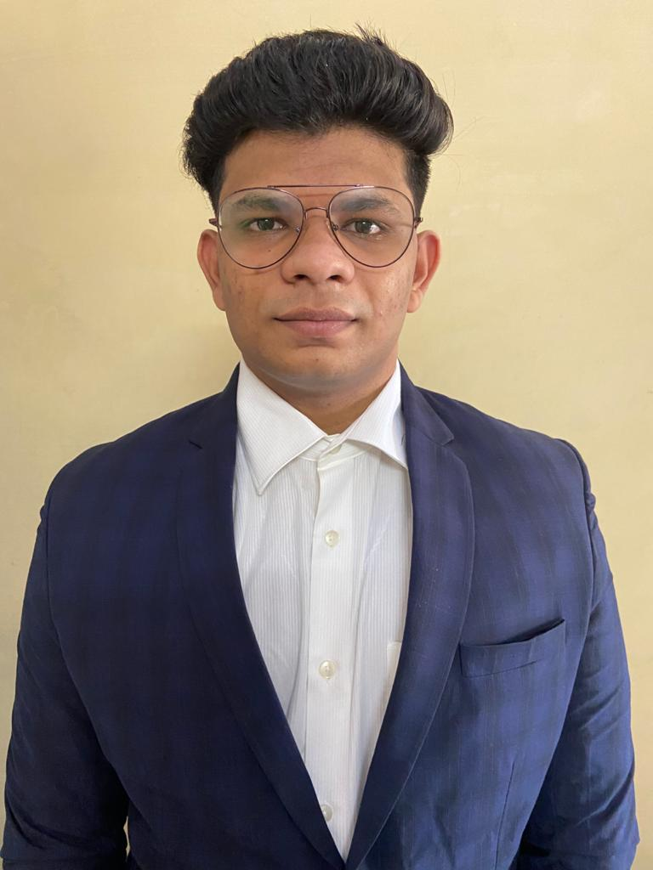

**Jayesh Ranjan Chaware**

**Course:**

MCA

,

**Date of Birth:**

03

/

09

/1998

,

**Area of Domicile:**

Nagpur, Maharashtra

**Email:**

jchaware4@gmail.com

**Mobile:**

+917083462500

**Address**

**:**

**-**

Ashtvinayak Bichhayat Kendra Surendragadh behind Veterinary College

Civil lines, Nagpur

–

440006

Maharashtra

, India.



# Objective

“To serve the company with my efforts and personality traits like hard work and determined nature and goal oriented approach coupled with my skills and knowledge gained during my learning period.”

|  |  |  |  |  |
| --- | --- | --- | --- | --- |
| **Educational Qualification** | |  |  |  |
| **Academic/Degree** | **Institute Name** | **University Name/Board** | **Percentage/CGPA** | **Year** |
| MCA | I.M.E.D, Pune. | Bharati Vidyapeeth (Pune) | Pursuing (86.53) | 2021 |
| B.Com(Computer Application) | G.S College of Commerce and Economics Nagpur | RTMNU | 69.9 % | 2019 |
| XII | Sandipani Junior College | HHSC | 66.15 % | 2016 |
| X | Kendriya Vidhyalaya, Nagpur | CBSE Board | 6.4 | 2014 |

|  |  |
| --- | --- |
| **Technical Skills** |  |
| **Operating System** | Windows |
| **Software Knowledge** | Eclipse IDE, Netbeans IDE, Wamp/Xamp , MySQL Workbench, Microsoft Office, Microsoft Visual Studio, Microsoft Visual Code. |
| **Language Known** | C, C++, Java, C# .Net ,HTML5 , CSS, JavaScript, Python, PHP,VB.Net |
| **Database Known** | MySQL |

|  |  |  |  |
| --- | --- | --- | --- |
| **Academic Projects Undertaken** | |  |  |
| **Title** | **Year** | **Technology** | **Highlights** |
| **Automatic Timetable Generator** | BCCA final year  2018 | Java and MySQL | Working on Automatic Time Table generator where you can insert teachers with their subjects and load per subject and it will give timetable for 3 years as output, currently feasible only possible for BCCA Department of G.S College Nagpur . |
| **Learners** | MCA semester ii  2020 | Java and MySQL | A learning application which allows user to learn different courses online. And also allows teacher to add courses through YouTube or other platform. As we are playing video on other platform so it doesn’t need a huge database. |

|  |  |  |  |
| --- | --- | --- | --- |
| **Teachers Module for University Website** | MCA semester iv 2021 | HTML 5, CSS, JavaScript, MySQL | In teachers module all personal and professional detail of teacher is saved. Users can see professional details and admin and teacher can view and edit the personal and professional information. |

# Internships

* **Company-** IncubXperts
* **Languages-** C#.VET, ASP.NET
* **Duration-** 2 Months

# Extra-Curricular Activities & Achievements

* Participated in State Level Student Seminar at Wardha (2018)
* Participated in inter college model making competition (2018)
* Participated in IOSOMNIAC(12 hour overnight competition) (2019)
* 1st in I.M.E.D Gems Pune (2019, 2020, 2021)
* Member of Organizing committee, and leader of multiple events in IMED Gems, C-Googly , Xpressions.
* Participating in inter college football tournament (Since 2014)
* 1st Position in inter department football tournament in Sandipani collage(2015 & 2016)
* Participate in University level Football league(2017-2019)
* Industries visited (Jaipur Foots, Value Labs, Bisleri International)

# Strengths

Leadership, Team Player, Punctual, Hardworking, Self-motivated, Deterministic.

|  |  |
| --- | --- |
| **Personal Details** |  |
| **Father’s Name** | Mr. Ranjan Chaware |
| **Nationality** | Indian |
| **Marital status** | Unmarried |
| **Linguistic ability** | English , Hindi and Marathi |
| **Interests** | Coding, Art and Painting, Photography and Video making, Music, Sports |

# Declaration

I hereby declare that the information furnished above is true to the best of my knowledge.

Place: PUNE